**Hong Kong Institute of Vocational Education (Tsing Yi)**

**Department of Information and Communications Technology**

**HD in Game Software Development (IT114107)**

**ITP4913M Final Year Project**  
**(2017/2018)**

**Noah**

Turn-based Strategic Game with 3D Character on Android and PC Platform

|  |  |
| --- | --- |
| Supervisor: | Wilson CHO |
| Co-supervisor: | Eddie Chan |
| Student: | LAM Ka Kuen  CHIU Man Hin  IP Hau Man  MO Chun Tat |

We declare that this is a group project and that no part of this submission has been copied from any other student’s work or from any other source except where due acknowledgement is made explicitly in the text, nor has any part been written for us by another person.

|  |  |  |
| --- | --- | --- |
| **Student** | **Contribution to the project (%)**  **(Total 100%)** | **Signature** |
| LAM Ka Kuen | 25 |  |
| CHIU Man Hin | 25 |  |
| IP Hau Man | 25 |  |
| MO Chun Tat | 25 |  |

# Abstract

Noah is a fantasy world where involve magic and technology. There endless dispute between different forces in Noah mainland. The main character who is a hunter living in a small village. The conflict between different countries are become fiercer and his village cannot escape from the war. In the chaos world, how he can survive?

Noah is a turn-based strategy (TBS) game in PC. Player can experience the strategic battle by controlling the character. Noah is not a traditional turn-based strategy game like “Fire Emblem” series and “Super Robot War” series that are the “weapon versus weapon” battle. Noah contains more strategic way of battle, for example the trap system. Player needs to strategically to select the trap and design how to bait the enemies and knock them down. Player can interact with the battle environment like tree in the forest. Player can discover more and more play style which is suitable and funny to the player.

With the AR technology, Player can interact with the character they like and play the mini game with the character to strengthen the relationship between player and the character. It leads to the player belonging to the game.

# Table of Content

Abstract 2

Table of Content 3

Introduction 4

Game Design 5

Basic constraints and requirements 5

Design Thinking – Empathy 6

Design Thinking – Define 7

Design Thinking – Ideate 8

Game Overview 10

Story 10

System Architecture (Clients, Server and Database connections in your system) 20

Game World 21

Game Environment 21

Level Design 22

Maps Design 30

Characters 31

Enemies 45

Gameplay Description 47

Single Player Mode 47

Multi-Player Mode 47

User Interface Design 48

PC Control 49

Android Control 49

Objects 50

Software Design 52

Use Case Diagram 52

Sequence Diagrams 56

Database Design 58

Hardware and Software Requirements 60

AmazonBasics 3 Button USB 60

AmazonBasics 3 Button USB 61

AmazonBasics 3 Button USB 61

Technical Considerations 63

Project Plan 65

Schedule 65

Milestone Description 66

Action Plan for (the first Prototype) 67

References 68

Appendices 69

Workload Distribution 69

Budget Estimation (Reference) 70

Log Sheets 71

# Introduction

Noah is a turn-based strategy game with 3D world in PC and Android. It is a fantasy visual style background which involves the magic and technologies elements. The story is about the conflicts between the Magic Kingdom and Technology Empire become fiercer. Player needs to control the main character Fason to survives in the world. In the game world, player needs to fight against a lot of enemies by using different strategies such as using the battle environment, placed the trap to bait the enemies and conduct a team fighting.

The target player of the game is the player who likes to play tuned-based style strategy game or wants to experience the new game mechanic. Also, the game is attracting the player who likes the fantasy story and RPG style adventure game.

With comparison of different similar games, we decide the different game mechanic and new AR technologies to allow player to have a new experience. Most of the turn-based strategy game like Super Robot War, Fire Emblem and SD Gundam G Generation series are traditionally to strengthen the character that can fight against the enemies by stronger character. They are mainly focus on the character’s power and different type of the character (warrior, magician, shooter, etc.). In contrast, Noah is more focus on the strategy part. We decide the different battle environment with different obstacle, different items for player to interactive with environment by using the specific items and the character’s abilities. For example, player can use the rope tied between two trees to knock down the enemies. Player can place the trap to bait the enemies to complete different mission. Player can not only focus on how to strengthen their character to pass the levels, also strategically win the game.

For the pros, as the above difference, we make the game more strategy. It is suitable for the player who are tired in traditional TBS game. The new AR technology can make interaction between the character and player can also attract the player to play the game. For the cons, player may need more time to think about the strategies, it leads player to use more time for planning, study different environment, the different abilities of different character and the items.

This document is covering the game overview, game world with different levels, gameplay description. Also, the development part is including the hardware and software requirement, technical considerations, project plan and the action plan for the first prototype. Final is the appendices which includes the workload distribution and the budget estimation.

# Game Design

## Basic constraints and requirements

* This project requires 8 months development including the research, game design and development project, implementation and testing. The detail of the development timeline can refer to the Development Timeline pages.
* Unity game engine and the 3Ds Max are the requirement of the main development to build the whole game. The main game player is developed by Unity and the characters and the environment designs of the game world are developed by 3Ds Max.
* This project requires the 3-tiers architecture which contains client, server and database. This architecture allows player to store the requires game information like game account and multi-player mode for further maintenance and management.
* This project also requires the AR technology which supported by Vuforia. It uses to develop the attractive interaction between player and the character in the game.

## Design Thinking – Empathy

Describe the user experience on similar games in the market (both pros and cons)

**Disgaea series**

**Pros:**

* **Multiple endings (Disgaea: Hour of Darkness – 6different ending)**
* **Story is humor**
* **Many character development elements**

**Cons:**

* **Graphics performance is not attractive**
* **Play rules is quite traditional**

**Fire Emblem series**

**Pros:**

* **Epic music**
* **Amazing character and graphics design**

**Cons:**

* **All the series are similar theme (Always defeat dragon at the end fight)**
* **Fighting system are too simple all the series (only fighting element to defeat enemy)**

**Super Robot War series**

**Pros:**

* **Various skills to attack enemy**
* **Many epic attack animation**

**Cons:**

* **Use the same character through most of the series (Gundam Seed appeared most of series with same attack skills)**
* **Too easy to beat the levels**

**SD Gundam G Generation series**

**Pros:**

* **Attractive battle animation**
* **Many types of character and robot for player to choose**

**Cons:**

* **Focus on character development while less the strategic elements in battle**
* **The story is similar in different series and less dramatic**

## Design Thinking – Define

What elements could make your game more enjoyable?

List the reframe the needs and insight

* The main element of this game is to strengthen the strategy elements in turn-based strategy (TBS). The traditional TBS are mainly focus on the character’s power and different type of the character. In contrast, we decide the different battle environment with different obstacle, different items for player to interactive with environment by using the specific items and the character’s abilities. Player can place the trap to bait the enemies instead of direct battle to complete different mission.
* The new AR technology which allows player to experience the 3D character. Player can enjoy the character they like by interaction. For example, player can shoot a photo in real world with their character by using the AR technology.

## Design Thinking – Ideate

* **One story line with multiple ending:** Player can more easily to know what happen in the story and more focus on the game play. The multiple endings allow player to make different decision to experience the different ending.

**Advantages:** The multiple ending can be the replacement of the “Multi Story Line” that is similar advantages of making different experience for player to enjoy the story.

**Disadvantages:** Player may not fulfil with the story as the advantages of multi-story line mode.

* **Team Supporting System:** Each character has unique advantage and disadvantage properties that affects the battle. For example, the “Tank” character is responsible for absorb the enemies attack while this character is hard to attack the enemies in efficient way. If he is battle with another weaker defense character but can hit the enemies effectively, the battle can be more easily to win.

**Advantages:** Player can strategically think about how to set the group of character to strengthen the character.

**Disadvantages:** Player may need more time to learn each character’s features to realize this tactic.

* **Item Compose System:** Player can collect the specific item to compose the different useful item such as the health potion, trap items even the equipment.

**Advantage:** Player can freely compose the items or equipment they want.

**Disadvantages:** Player needs to collect the specific materials to create what they want.

* **3 different force to let player select:** Player can experience various ending and various characters in 3 various levels

**Abandoned Reason:** Instead of technical problem, time is the most essential problem for developing so many content. Therefore, we choose to focus on the game play

**\*The following are abandoned:**

* **Multi-Story Line:** Player can experience the different perspective of the whole story by making different decision. Player can be a part of union in the story to join the opposite battle during the story.

**Advantages:** Player can know more the detail of the story through the different story line.

**Abandoned Reason:** while it may lead the player to experience more than one times the whole process of the story. We need to make more contrastive game play and story that cannot fulfill the requirement of the game development time.

* **PVP Mode:** Player can versus another player through network

**Advantages:** Player can experience the exciting competition through this mode.

**Abandoned Reason:** It takes too much time per game, but if we have time limited control, the strategies elements will reduce. Therefore, this mode easily make player lost their interest in the game.

* **Main Character was a swordsman:** The main male character of the game was decided to be a swordsman that great at using sword

**Advantages:** Player may easily handle the game play by previous similar experience.

**Abandoned Reason:** Every SRPG’s main character are using sword. To make our game a little bit different, we decided the main characters career is hunter that can use trap. This might attract player to notice the game

# Game Overview

## Story

Noah is a fantasy world where involve magic and technology. There endless dispute between different forces in Noah mainland. The main character Fason who is a hunter living in a small village. The conflict between different countries are become fiercer and his village cannot escape from the war. Fason hunted and back to the village, he only sees the red blood flowing as a river around the village, and the solders of Technology Empire was killing a villager. The solder killed all the witness to prevent the Magic Kingdom know their trace. Fason is found by the solder. Fason then escaped from the solders by the helps of a girl, Lisa. Lisa is a magician of Magic Kingdom, she needs to fight against the Technology Empire, Fason take the risk with her. The revenge of Fason is begin.

**Refer to the following flowcharts for the details of the game play logic:**

**Main Game Play Flowchart :**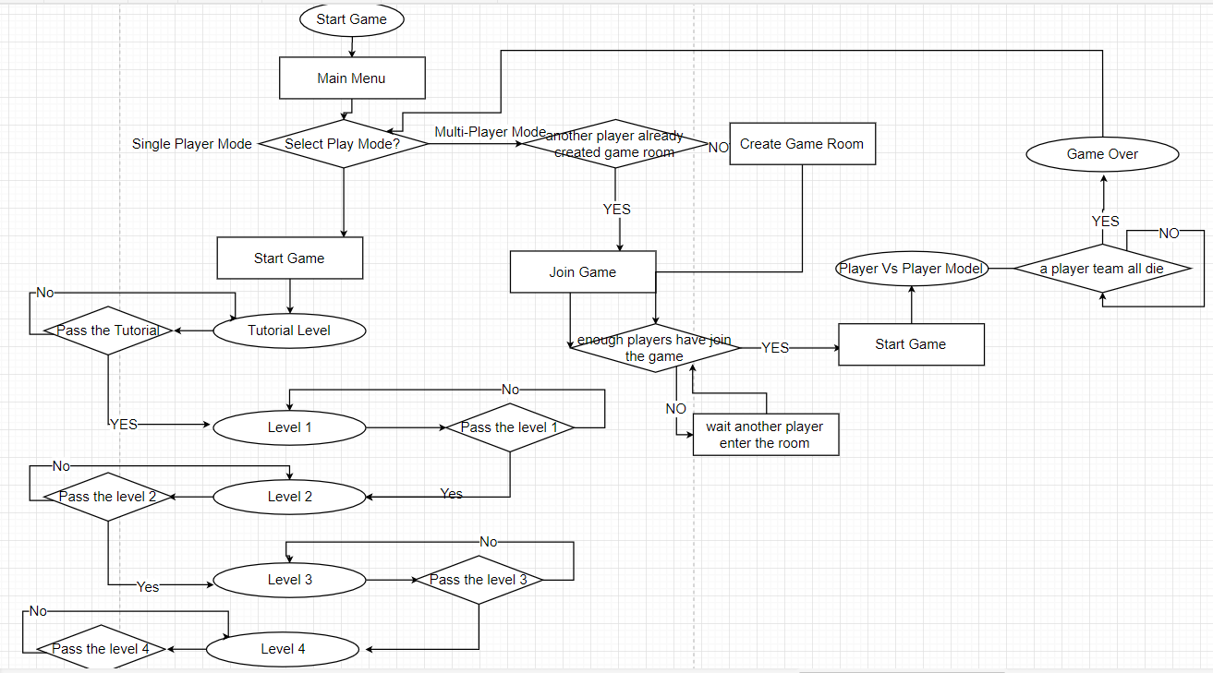

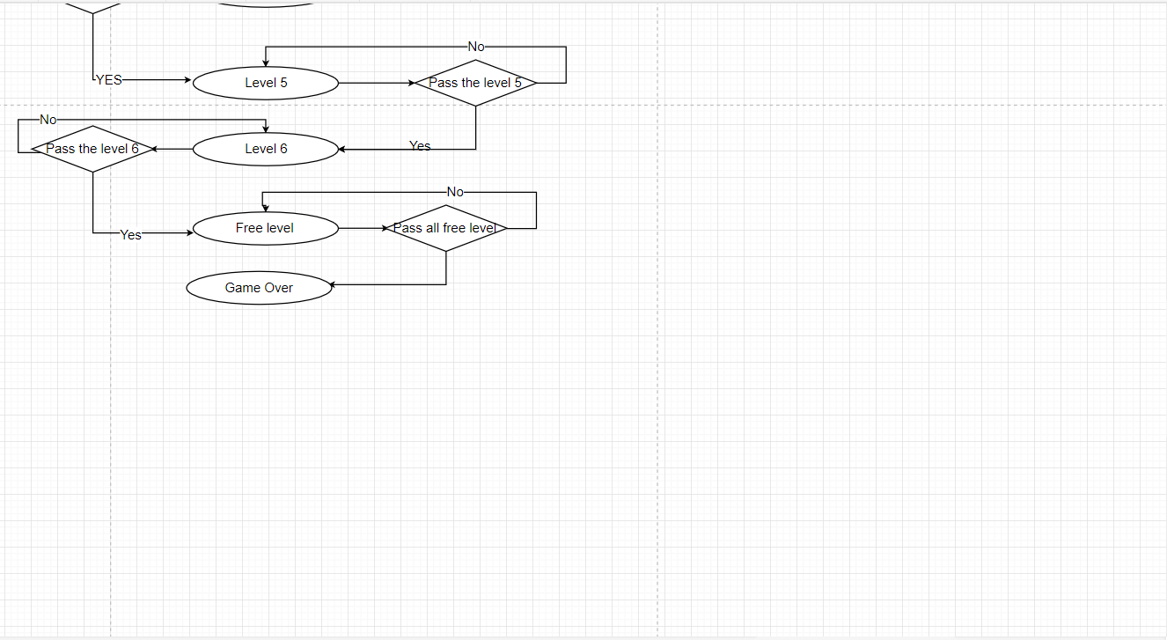

**Tutorial Level:**

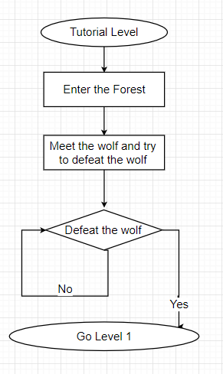

**Level 1:**

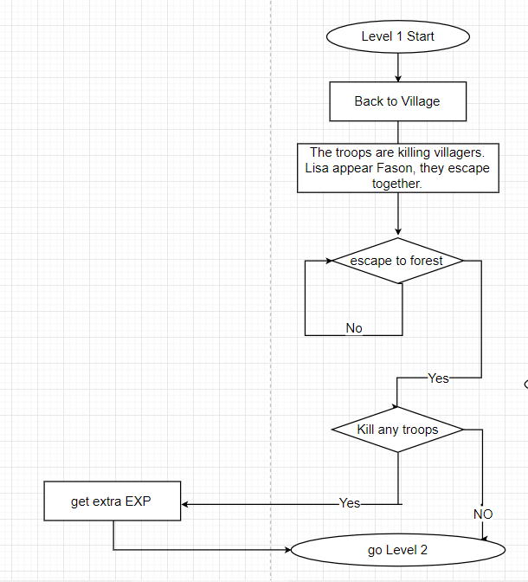

**Level 2**

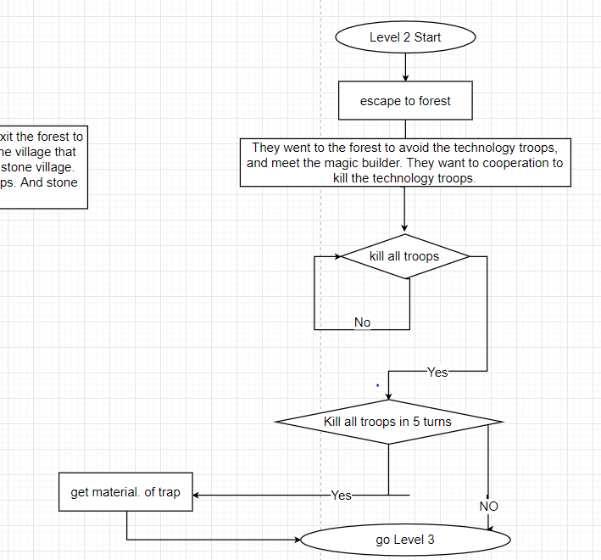

**Level 3**

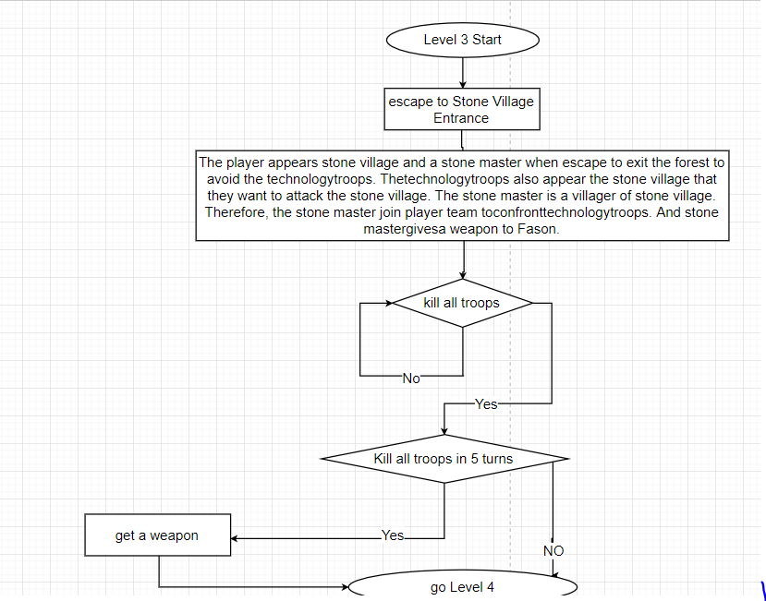

**Level 4**

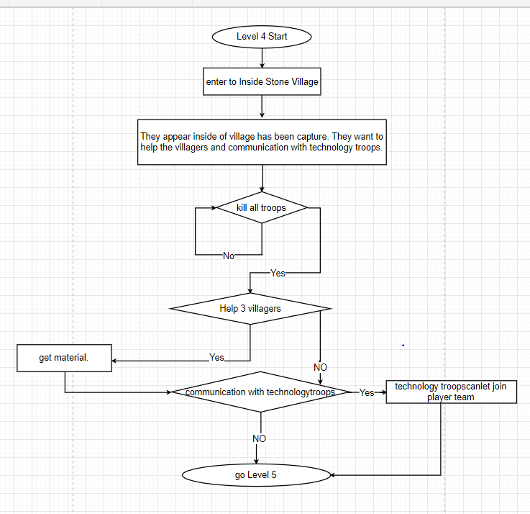

**Level 5**

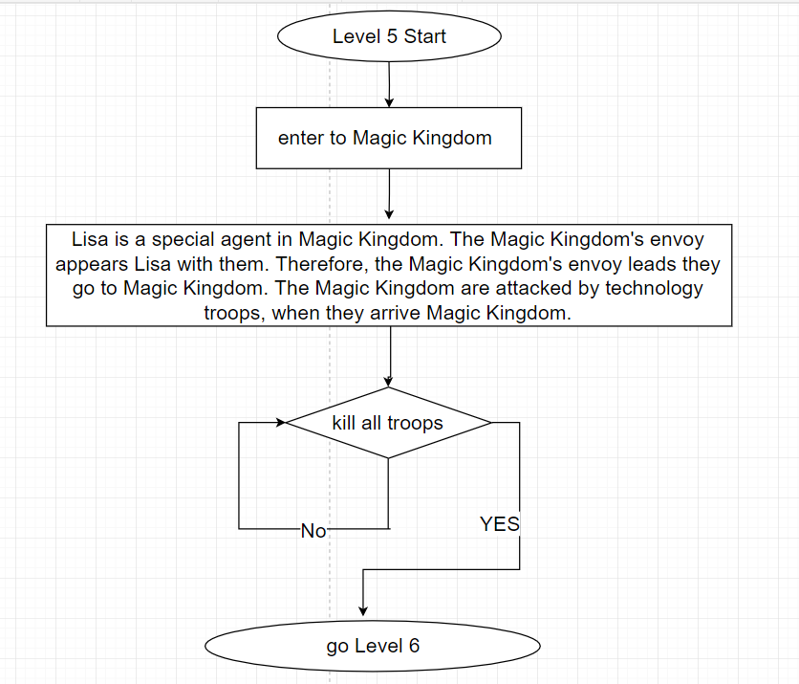

**Level 6**

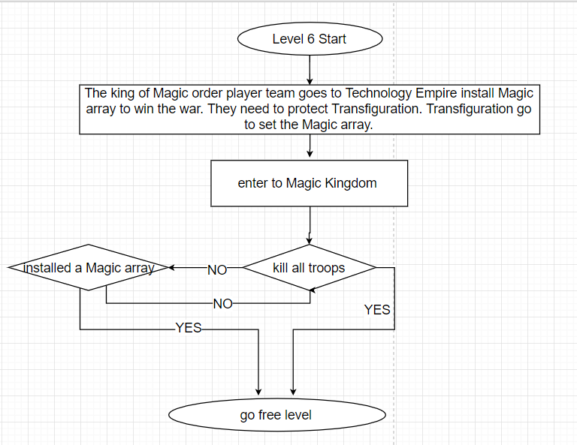

**Free level**

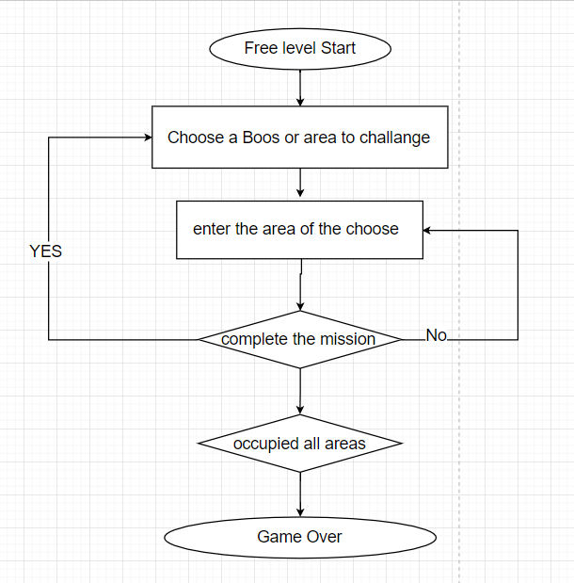

## System Architecture (Clients, Server and Database connections in your system)

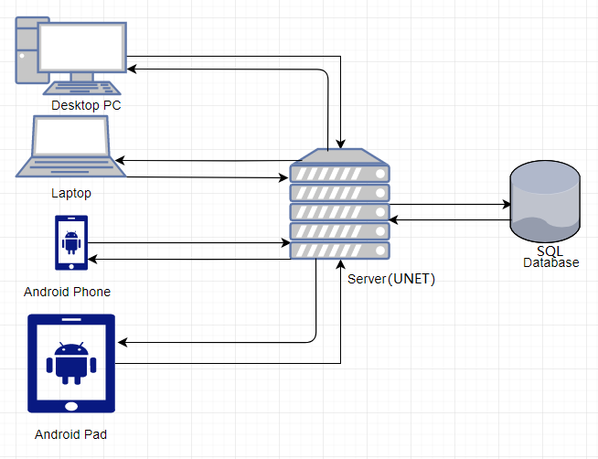

* Client needs to access the database through the server to login the game.
* Client characters’ information is stored in the database
* All the account information of client will be stored in database.
* In multi-player mode, the database stored the level information such as unit’s attributes, unit’s position in the battle environment.

# Game World

## Game Environment

The game takes place in a fantasy world where involve magic and technology. There are 5 levels and each level is in a place of the world. The detail game environment of each level is shown in the level design below. The game world has two cultures, magic and technology, they are against each other. Furthermore, the world has different race (e.g. magic and technology). These will be further elaborated in the Character and Object Design section.

## Level Design

**Tutorial Level:**

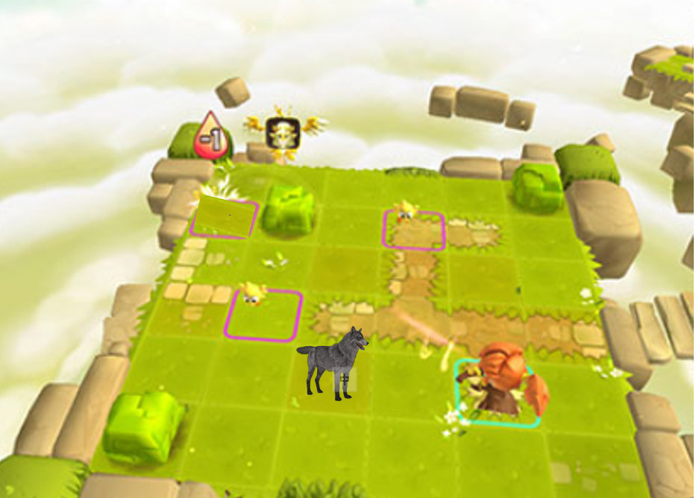

|  |  |
| --- | --- |
| Concept: | Complete missions or loss the level. |
| Environment: | A map in forest with Fason and a wolf. |
| Beginning: | The player starts in the deep of the forest, he wants to catch a wolf. |
| Ending: | Player use the trap to catch the wolf and kill it. (success). |
| Goal: | Use trap to catch the wolf and kill it. |
| Challenge: | Attacked by wolf. |
| Reward: | Player can go to next level and receive a development of story. |
| Failure: | Restart the level. |

**Level 1: Village**

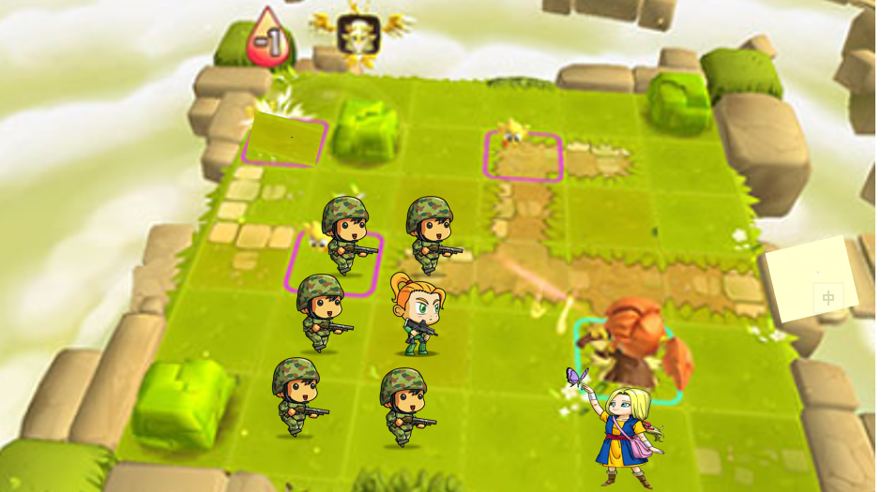

|  |  |
| --- | --- |
| Concept: | Complete missions or loss the level. |
| Environment: | A map in village with Fason, Lisa, too many technology troops and too many corpses of villagers. |
| Beginning: | The player starts in the entrance of the village, the troops are killing villagers. Lisa appear Fason, they escape together. |
| Ending: | Player use the trap to avoid the technology troops and exit the village (success). |
| Goal: | Arrive a specified position of the map. |
| Challenge: | Attacked by too many troops and cannot be catch. |
| Reward: | Player can go to next level and receive a development of story. |
| Failure: | Restart the level. |
| Special mission | Kill any troop can get extra EXP | |

**Level 2: Forest**

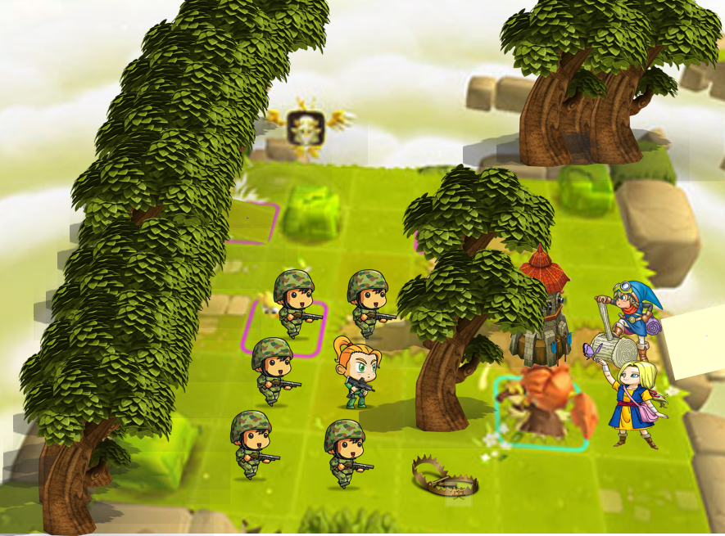

|  |  |
| --- | --- |
| Concept: | Complete missions or loss the level. |
| Environment: | A map in forest with Fason, Lisa, too many technology troops and a magic builder. |
| Beginning: | They went to the forest to avoid the technology troops, and meet the magic builder. They want to cooperation to kill the technology troops. |
| Ending: | Player use the trap to catch the technology troops. Magic builder uses his magic of building to create some shooting tower to kill the technology troops. Technology troop's reinforcement arrived. Fason, Lisa and builder escape again.(success). |
| Goal: | Kill all the troops. |
| Challenge: | Attacked by too many troops and cannot all be kill. |
| Reward: | Player can go to next level and receive a development of story. |
| Failure: | Restart the level. |
| Special mission | Kill all troops in 5 turns can get material. | |

**Level 3: Stone Village Entrance**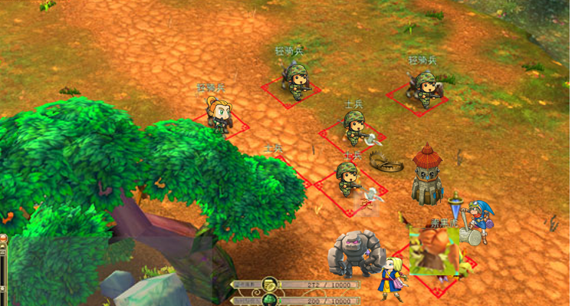

|  |  |  |
| --- | --- | --- |
| Concept: | | Complete missions or loss the level. |
| Environment: | | A map in Stone Village entrance with Fason, Lisa, a builder, too many technology troops and a stone master. |
| Beginning: | | The player appears stone village and a stone master when escape to exit the forest to avoid the technology troops. The technology troops also appear the stone village that they want to attack the stone village. The stone master is a villager of stone village. Therefore, the stone master join player team to confront technology troops. And stone master gives a weapon to Fason. |
| Ending: | | Player team repel technology troops, they enter the stone village. (success). |
| Goal: | | Kill all the troops. |
| Challenge: | | Attacked by too many troops and cannot all be killed. |
| Reward: | | Player can go to next level and receive a development of story. Open recruiting function. |
| Failure: | | Restart the level. |
| Special mission | Kill all troops in 5 turns can get a weapon. | | |

**Level 4: Inside Stone Village**

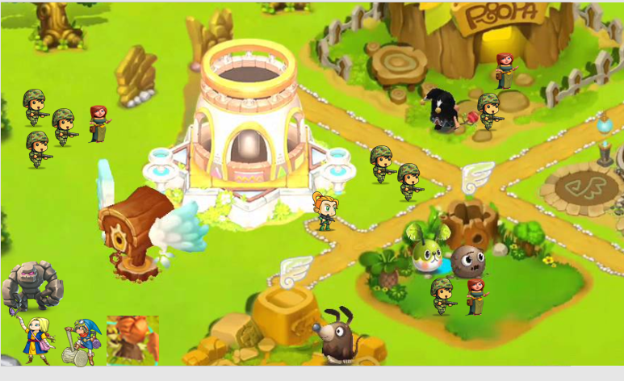

|  |  |
| --- | --- |
| Concept: | Complete missions or loss the level. |
| Environment: | A map in Stone Village with Fason, Lisa, a builder too many technology troops, villagers and a stone master. |
| Beginning: | They appear inside of village has been capture. They want to help the villagers and communication with technology troops. |
| Ending: | Player team repel technology troops, they helped the stone village. |
| Goal: | Kill all the troops. Help the villagers and communication with technology troops. |
| Challenge: | Attacked by too many troops, help villagers and communication with technology troops. |
| Reward: | Player can go to next level and receive a development of story. |
| Failure: | Restart the level. |
| Special mission | Help 3 villagers can get material. OR communication with technology troops can let join player team |

**Level 5: Magic Kingdom**

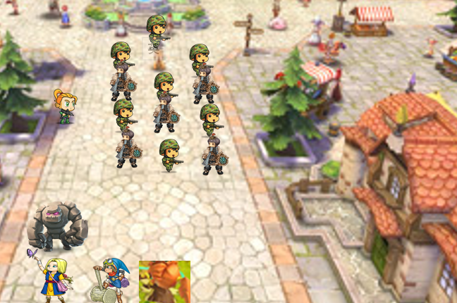

|  |  |
| --- | --- |
| Concept: | Complete missions or loss the level. |
| Environment: | A map in Magic Kingdom with Fason, Lisa, a builder too many technology troops, magic troops and a stone master. |
| Beginning: | Lisa is a special agent in Magic Kingdom. The Magic Kingdom's envoy appears Lisa with them. Therefore, the Magic Kingdom's envoy leads they go to Magic Kingdom. The Magic Kingdom are attacked by technology troops, when they arrive Magic Kingdom. |
| Ending: | Player team repel technology troops. They go to meet the king of Magic Kingdom. |
| Goal: | Kill all the troops. Help the villagers and communication with technology troops. |
| Challenge: | Attacked by too many troops, help villagers and communication with technology troops. |
| Reward: | Player can go to next level and receive a development of story. |
| Failure: | Restart the level. |

**Level 6: Technology Empire** 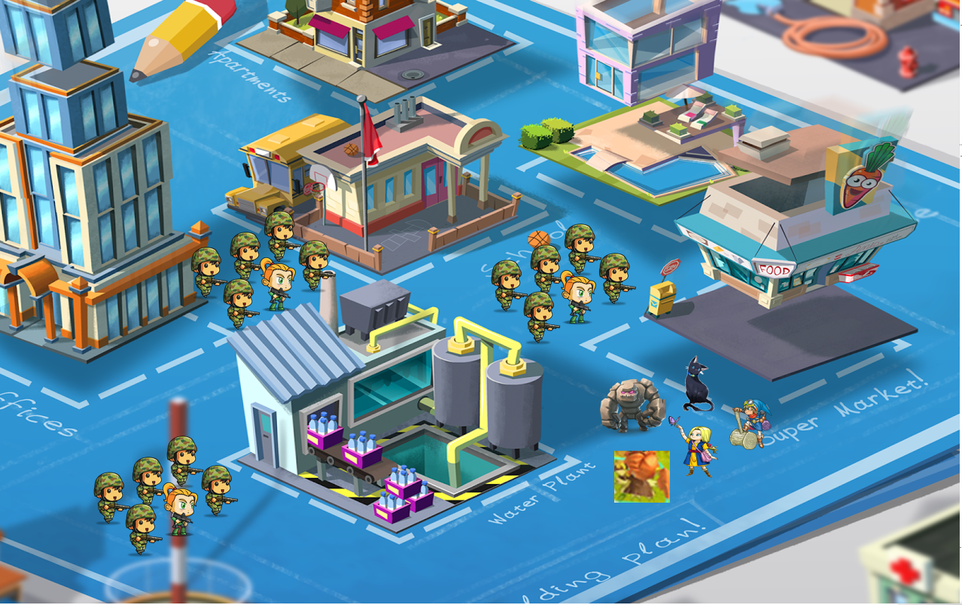

|  |  |
| --- | --- |
| Concept: | Complete missions or loss the level. |
| Environment: | A map in Technology Empire with Fason, Lisa, a builder too many technology troops, magic troops, transfiguration and a stone master. |
| Beginning: | The king of Magic order player team goes to Technology Empire install Magic array to win the war. They need to protect Transfiguration. Transfiguration go to set the Magic array. |
| Ending: | Player team success installed a Magic array. Magic Kingdom win the war. |
| Goal: | Protect Transfiguration to arrive a specified position to install Magic array. |
| Challenge: | Attacked by too many troops, arrive a specified position to install Magic array, Transfiguration cannot die. |
| Reward: | Player can go to next level and receive a development of story. Open free level. |
| Failure: | Restart the level. |

**Free level: Different area (Support Multiplayer)**

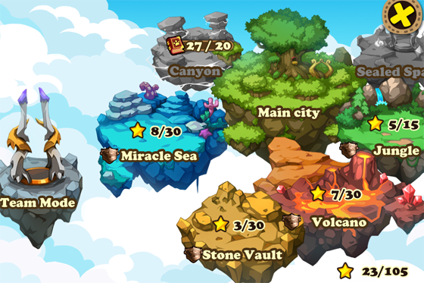

|  |  |
| --- | --- |
| Concept: | Complete missions or loss the level. |
| Environment: | Different Boos Map |
| Beginning: | Player decided help Magic Kingdom occupied different area in the world. |
| Ending: | Keep go different areas to kill the boss. |
| Goal: | Kill different Boss. |
| Challenge: | Attacked by too many different Monster. |
| Reward: | Level up, money, weapon, character. |
| Failure: | Restart the level. |

## Maps Design

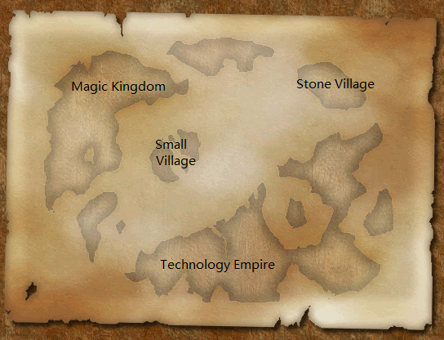

## Characters

**Main Boy Character**

**Fason - Hunter**

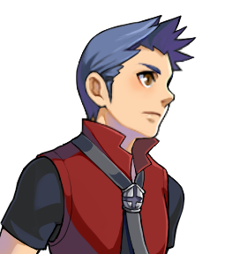

Fason is the main character of the game. He is a hunter in the world. He need help Magic Kingdom occupied different area in the world.

**Attributes:**

|  |  |  |
| --- | --- | --- |
| Attribute | Description | Default Value |
| Health Point (HP) | The health point of Pater | 200 |
| Energy | It decreases when Pater use skill. | 100 |
| Speed | How far Pater can walk in one frame. | 5 |
| Attack | The attack values of Pater | 20 |
| Attack distance | Pater can attack the NPC within the distance. | 1 |

**Abilities:**

1. He can use defensive (防守) skill to withstand NPC’s attack. He spends 5 energies. He will let hurt -50%.

1. Fason has 4 types of attacks:

|  |  |  |  |  |
| --- | --- | --- | --- | --- |
| Attack Name | Description | Skill distance | Default Damage | Energy |
| Shooting attack | Use arrow to shoot NPC | Attack distance *3 | Attack * 1 | 0 |
| Sky shooting | Jump to sky use arrow shoot NPC | Attack distance *5 | Attack * 2 | 30 |
| Set trap | Use some item to set a trap in a position, when NPC through the trap, it cannot move | Attack distance *1 | 0 | 20 |
| Multiple hooting | Shoot 5 arrows to attack NPC in a same time (this can attack 1-5NPC) | Attack distance *3 | Attack * 1.5 | 50 |

**Main Girl Character**

**Lisa –Fire Master**

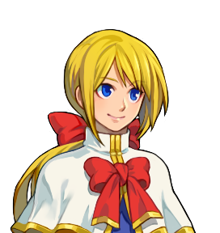2

Lisa is a special agent in Magic Kingdom. She need to complete the mission of Magic Kingdom and help Magic Kingdom install a Magic array in Technology Empire.

**Attributes:**

|  |  |  |
| --- | --- | --- |
| Attribute | Description | Default Val |
| Health Point (HP) | The health point of Pater | 150 |
| Energy | It decreases when Pater use skill. | 50 |
| Speed | How far Pater can walk in one frame. | 4 |
| Attack | The attack values of Pater | 15 |
| Attack distance | Pater can attack the NPC within the distance. | 1 |

**Abilities:**

1. She can use defensive (防守) skill to withstand NPC’s attack. She spends 5 energies. She will let hurt -50%.

1. Fason has 5 types of attacks:

|  |  |  |  |  |
| --- | --- | --- | --- | --- |
| Attack Name | Description | Skill distance | Default Damage | Energy |
| Reply | Use a Magic to reply team mate or own HP | Attack distance *2 | Attack * 3  (Reply) | 30 |
| Fire ball | Use a Magic fire ball shoot to other NPC | Attack distance *2 | Attack * 3 | 30 |
| Big Fire ball | Use a Magic big fire ball shoot NPC | Attack distance *3 | Attack * 5 | 80 |
| Fire band | A band of fire. Round the character 1 distance would be hurt. | Attack distance *1 | Attack * 5 | 150 |
| Attack | Use hand to attack NPC | Attack distance * 1 | Attack * 1 | 0 |

**Santer – Build Master**

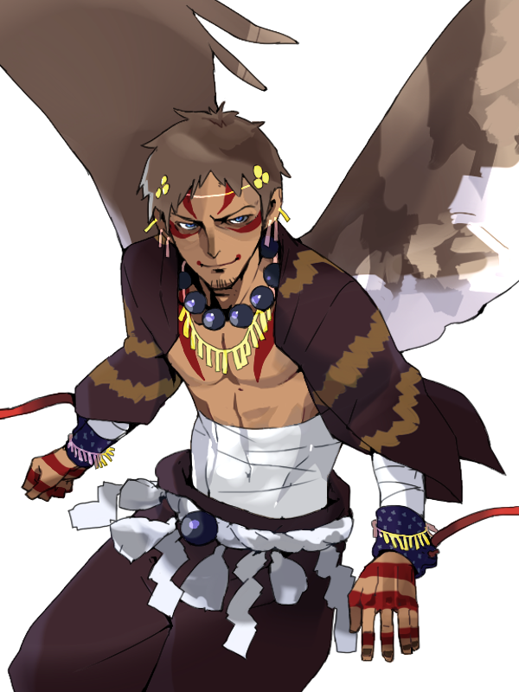

Santer is a magic builder. He in a forest meet Fason and join player team to repel technology troops

**Attributes:**

|  |  |  |
| --- | --- | --- |
| Attribute | Description | Default Value |
| Health Point (HP) | The health point of Pater | 200 |
| Energy | It decreases when Pater use skill. | 150 |
| Speed | How far Pater can walk in one frame. | 4 |
| Attack | The attack values of Pater | 15 |
| Attack distance | Pater can attack the NPC within the distance. | 1 |

**Abilities:**

1. He can use defensive (防守) skill to withstand NPC’s attack. He spends 5 energies. He will let hurt -50%.

1. Fason has 4 types of attacks:

|  |  |  |  |  |
| --- | --- | --- | --- | --- |
| Attack Name | Description | Skill distance | Default Damage | Energy |
| Build shooting tower | Use a Magic to build a shooting tower | Attack distance *1 | Attack * 2 | 40 |
| Attack | Use hand to attack NPC | Attack distance * 1 | Attack * 1 | 0 |
| Build MP Home | Player character can enter the home to reply their MP per turn | 0 | Attack * 2  (Reply) | 80 |
| Build wall | Use a Magic to build a wall let NPC cannot through | Attack distance *1 | Attack * 7  (wall HP) | 20 |

**Papa –Stone Master**

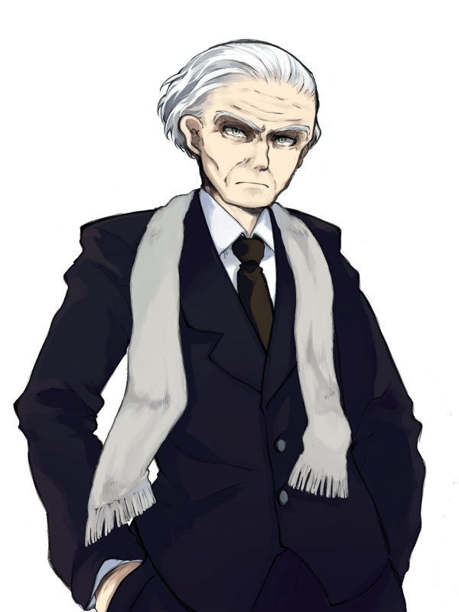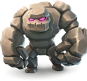

Papa is a Stone Master and stone village's villagers. He in a Stone Village Entrance meet Fason and join player team to repel technology troops

**Attributes:**

|  |  |  |
| --- | --- | --- |
| Attribute | Description | Default Value |
| Health Point (HP) | The health point of Pater | 250 |
| Energy | It decreases when Pater use skill. | 120 |
| Speed | How far Pater can walk in one frame. | 3 |
| Attack | The attack values of Pater | 20 |
| Attack distance | Pater can attack the NPC within the distance. | 1 |

**Abilities:**

1. He can use defensive (防守) skill to withstand NPC’s attack. He spends 5 energies. He will let hurt -50%.

1. Fason has 4 types of attacks:

|  |  |  |  |  |
| --- | --- | --- | --- | --- |
| Attack Name | Description | Skill distance | Default Damage | Energy |
| Petrochemical | Use a Magic to let himself change to a stone monster 3 turn. Attack values *2 and hurt –40% | / | 0 | 40 |
| Attack | Use hand to attack NPC | Attack distance * 1 | Attack * 1 | 0 |
| Stone ball | Use a Magic Stone ball  shoot to other NPC | Attack distance *2 | Attack * 3 | 30 |
| Big Stone ball | Use a Magic big Stone ball  shoot NPC | Attack distance *3 | Attack * 5 | 80 |

**Mimi – Original Transformed**

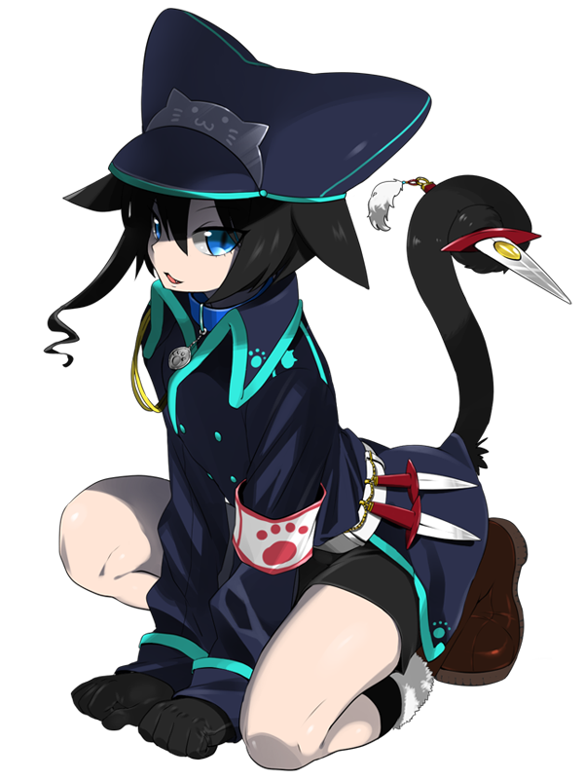 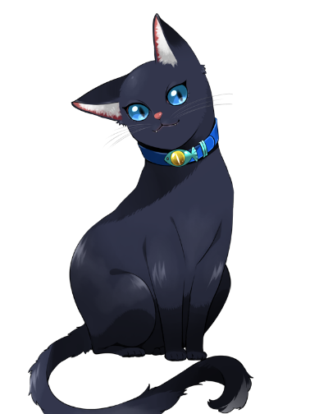

Mini is an original Transformed. Magic Kingdom order she follow player team to install a Magic array in Technology Empire.

**Attributes:**

|  |  |  |
| --- | --- | --- |
| Attribute | Description | Default Value |
| Health Point (HP) | The health point of Pater | 130 |
| Energy | It decreases when Pater use skill. | 200 |
| Speed | How far Pater can walk in one frame. | 5 |
| Attack | The attack values of Pater | 20 |
| Attack distance | Pater can attack the NPC within the distance. | 1 |

**Abilities:**

1. He can use defensive (防守) skill to withstand NPC’s attack. He spends 5 energies. He will let hurt -50%.

1. Fason has 4 types of attacks:

|  |  |  |  |  |
| --- | --- | --- | --- | --- |
| Attack Name | Description | Skill distance | Default Damage | Energy |
| Cat Transform | Change to a cat body 3 turn. Speed * 1.5. NPC would not attack she. | / | 0 | 40 |
| Attack | Use hand to attack NPC | Attack distance * 1 | Attack * 1 | 0 |
| Call cat team | Call too many cats to attack NPC | Attack distance *2 | Attack * 3 | 20 |
| Jump Grab | Jump to sky use 2 hands grab the NPC | Attack distance *3 | Attack * 5 | 50 |

**Non-player Character**

**Magic Kingdom's envoy**

He leads the player team to the Magic Kingdom.

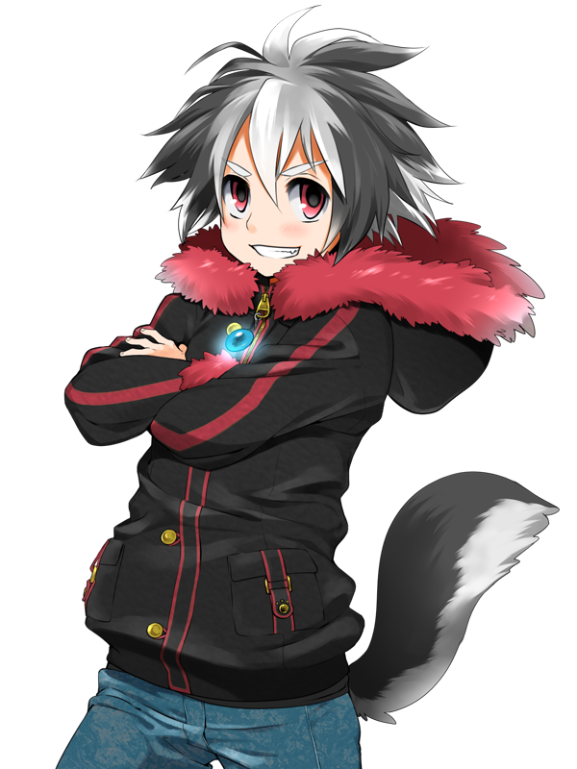

**Magic Kingdom's King**

This is the King of the Magic Kingdom.

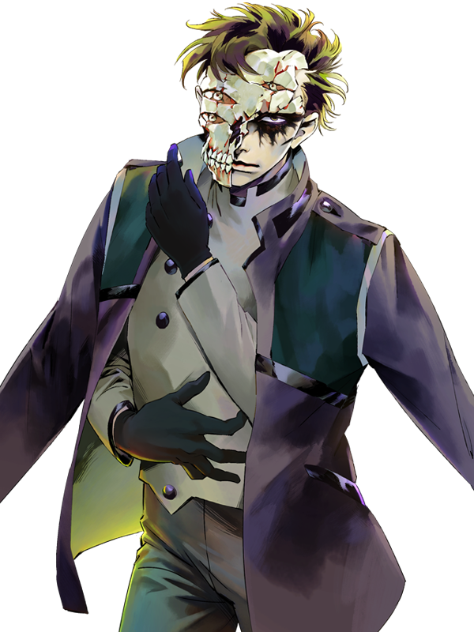

**Magic Troops**

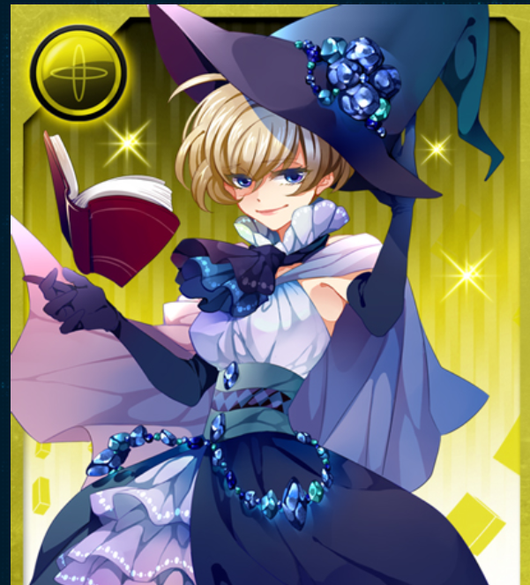

They help Technology Empire to occupied Magic Kingdom.

**Attributes:**

|  |  |  |
| --- | --- | --- |
| Attribute | Description | Default Value |
| Health Point (HP) | The health point of Pater | 150 |
| Speed | How far Pater can walk in one frame. | 5 |
| Attack | The attack values of Pater | 20 |
| Attack distance | Pater can attack the NPC within the distance. | 1 |

**Abilities:**

1. Fason has 4 types of attacks:

|  |  |  |  |
| --- | --- | --- | --- |
| Attack Name | Description | Skill distance | Default Damage |
| Light ball | Use light ball to shooting Technology Troops | Attack distance * 3 | Attack * 2 |
| Attack | Use hand to attack player | Attack distance * 1 | Attack * 1 |
| Big Light ball | Use Big light ball to shooting Technology Troops | Attack distance *5 | Attack * 1 |

## Enemies

**Technology Troops**

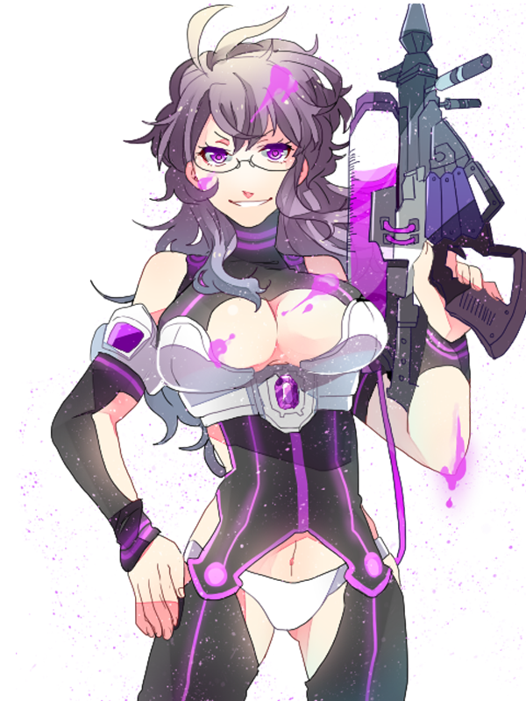

They help Technology Empire to occupied Magic Kingdom.

**Attributes:**

|  |  |  |
| --- | --- | --- |
| Attribute | Description | Default Value |
| Health Point (HP) | The health point of Pater | 150 |
| Speed | How far Pater can walk in one frame. | 5 |
| Attack | The attack values of Pater | 20 |
| Attack distance | Pater can attack the NPC within the distance. | 1 |

**Abilities:**

1. Fason has 4 types of attacks:

|  |  |  |  |
| --- | --- | --- | --- |
| Attack Name | Description | Skill distance | Default Damage |
| shooting | Use their gun to shooting player | Attack distance * 3 | Attack * 2 |
| Attack | Use hand to attack player | Attack distance * 1 | Attack * 1 |
| Sky shooting | Jump to sky use arrow shoot NPC | Attack distance *5 | Attack * 1 |

# Gameplay Description

This is turn-based strategy game and the main character Fason faces a lot of dangers and challenges from the enemies (Technology Empire). Fason needs to make a lot of decision to fight against the enemies by using different strategy to complete his revenge. Player will win the by complete the final mission, destroy Technology Empire’s nuclear weapon. Player will loss if all his teammate is killed by the enemies.

## Single Player Mode

* Player will follow the story of game to play
* Player needs to complete 5 level battle
* Player will have different mission on some level, one basic mission and one special mission. If player clear the mission, they will earn the specific rewards
* Player can compose item or weapon by collecting specific materials
* Player can control maximum of 5 character during the battle
* Player can use different abilities (skills) to fight against the enemies
* Player should be done all the character’s action in one turn, then enter the enemies turn.
* Player can use the trap item as obstacle to fight against enemies
* Before each battle, player can change characters’ equipment
* Expected duration for playing the game: 50 minutes (about 10 minutes for each level)

## Multi-Player Mode

* For 2 Players
* Each Player have their own screen
* Use Internet to connect players
* Players play in co-operative mode. Each player controls a team of unit and they work together to beat a team of computer unit to earn some special reward (equipment or materials)

## User Interface Design

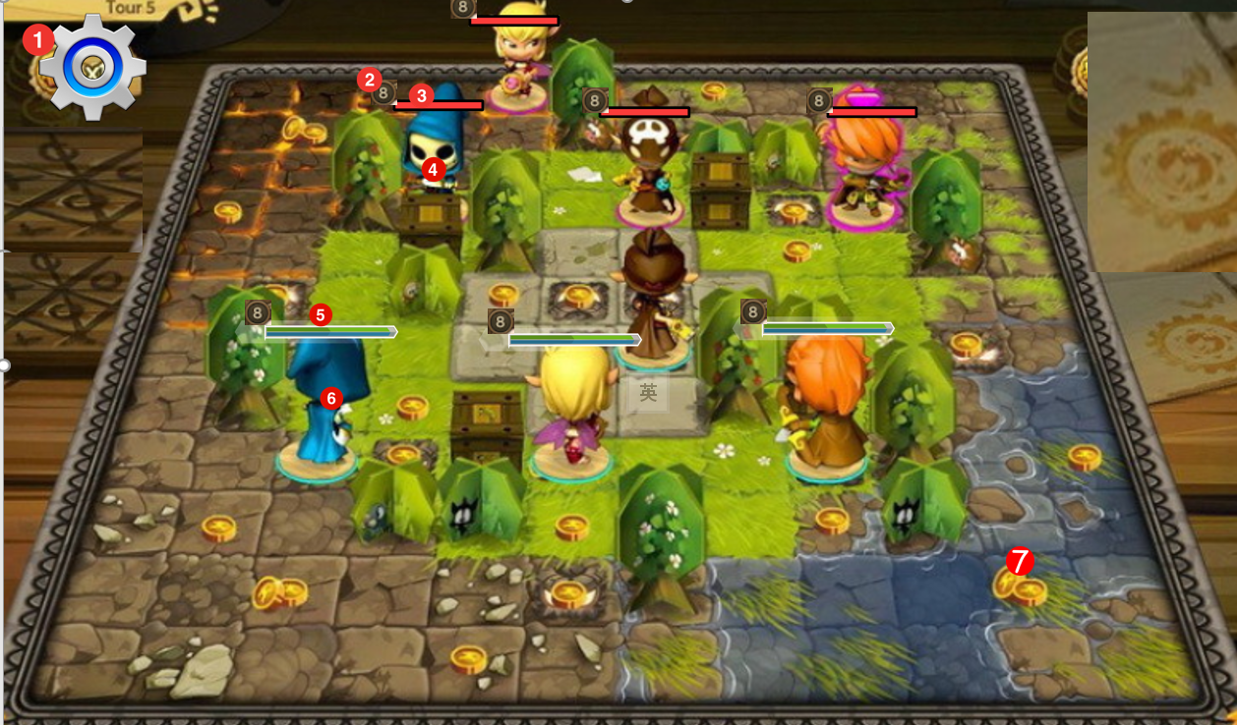

1. Setting Button

2.The character's Level

3.The NPC's HP bar

4.NPC

5.The player's character HP and MP bar

6. Player character

7.Special map

## PC Control

**Mouse Control**

|  |  |
| --- | --- |
| Button | Action |
| Left button | Click the button or make the choose |
| Right button | Move the camera |
| Mouse wheel | Zoom the camera |

**Keyboard Control**

|  |  |
| --- | --- |
| Button | Action |
| UP/LEFT/RIGHT/DOWN Button | Move the Camera |
| Esc Button | Call setting function |
| Enter or Space Button | Pass next talking scene |
| P Button | Pass all talking scene |

## Android Control

**Touch Control**

|  |  |
| --- | --- |
| Action | Description |
| Drag Screen by using two fingers | Move the Camera |
| Touch the object | Clicking function |
| Move two fingers from near to far (or change) | Zoom in / out the camera |

## Objects

Player need to get the key item, Magic Stone to beat the enemies (Technology Empire).

**Key Items**

|  |  |
| --- | --- |
| Name | Description |
| Magic Stone | Use to defend the nuclear weapon |

**Interactive world elements**

|  |  |
| --- | --- |
| Name | Description |
| Tree | Use to set a Rope trap |
| Ground | Use to build an Arrow Tour or set a Drop-Point |
| Big Rock | Use to set a Spring trap |

**Inventory Items**

|  |  |
| --- | --- |
| Name | Description |
| Rope Trap | Use to trap enemy that set on the tree and stop a unit action |
| Drop-Point | Use to trap enemy that set on the ground to damage a unit and stop an action |
| Spring trap | Use to trap enemy that set on the rock and damage enemy |
| Potion | Use to heal a unit |
| Horn | Use to increase the team's attack |
| Flag | Use to increase the team's defense |
| Arrow Tour | Use to damage enemy. It has health |

**Materials**

Materials will be dropped when player clear the level. player can collect different materials to create different inventory items.

|  |  |  |  |
| --- | --- | --- | --- |
| Name | Description | Rarity | Maximum Number of Stock |
| Wood | Use to create Flag and Drop-Point | Low | 99 |
| Metal | Use to create Arrow Tour, Spring Trap and Horn | High | 99 |
| Leaves | Use to Create Drop-Point and Potion | Low | 99 |
| Bottle of Water | Use to create potion | Low | 1 |
| Cloth | Use to create Flag and Rope Trap | Medium | 99 |
| Rock | Use to create Spring Trap, Horn and Arrow Tour | Low | 99 |

# Software Design

## Use Case Diagram

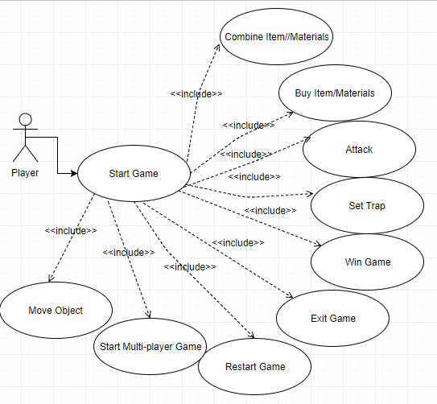

Primary Actor

|  |  |
| --- | --- |
| Actor | Description |
| Player | Player is who use the whole system to start a game to use different functions. |

Use Case Description

|  |  |
| --- | --- |
| Use Case ID | UC-01 |
| Use Case Name | Start Game |
| Use Case Description | Player can start the game. |
| Flow of Use Case | 1. Player can start the game by clicking the start game button in the main game menu 2. System ask player the game mode to be select 3. Player select the single player mode 4. System will create the required game object such as the game UI, non-player character and access the database to query for the player’s character information. |

|  |  |
| --- | --- |
| Use Case ID | UC-02 |
| Use Case Name | Combine Item / Material |
| Pre-condition | Player is using the inventory system |
| Use Case Description | Player can combine the items or materials to form new item |
| Flow of Use Case | 1. Player combine the items or materials by select more than two item in the combination UI. 2. System will check the combine list. If the recipe is in the system, the combination is success. Else the system will show the combine failed message. |

|  |  |
| --- | --- |
| Use Case ID | UC-03 |
| Use Case Name | But Item / Material |
| Use Case Description | Player can buy item or material from the NPC |
| Flow of Use Case | 1. Player talk to a NPC to buy item 2. System check the database of the NPC to show the item can be buy in the Shopping UI. 3. Player select a item to buy. 4. System check player have enough gold to buy the item 5. System return the success message if player have gold more than the price of the item. Else return the failed to buy message. |

|  |  |
| --- | --- |
| Use Case ID | UC-04 |
| Use Case Name | Attack |
| Use Case Description | Player can attack the enemy by controlling a character to attack in the battle board. |
| Flow of Use Case | 1. Player select a character and select the attack command. 2. System shows the attack range of the character. 3. Player select a valid enemy. 4. System calculate the damage from playing character to the enemy. 5. System show the damaged message. |

|  |  |
| --- | --- |
| Use Case ID | UC-05 |
| Use Case Name | Move Object |
| Use Case Description | Player can move an object in the battle board |
| Flow of Use Case | 1. Player select a character and select the move command. 2. System shows the move range of the character. 3. Player select a valid position. 4. System change the position of the character to the selected place. |

|  |  |
| --- | --- |
| Use Case ID | UC-06 |
| Use Case Name | Set Trap |
| Use Case Description | Player can set trap in the battle board |
| Flow of Use Case | 1. Player select a character and select the set trap command. 2. System shows the set trap range of the character. 3. Player select a valid position. 4. System set the trap in the position of the character to the selected place. |

|  |  |
| --- | --- |
| Use Case ID | UC-07 |
| Use Case Name | Restart Game |
| Use Case Description | Player can restart the game when player lose the battle |
| Flow of Use Case | 1. Player select the restart button 2. System reload the last data stored in the database and restart the battle. |

|  |  |
| --- | --- |
| Use Case ID | UC-08 |
| Use Case Name | Start Multi-Play Game |
| Use Case Description | Player can start the game in multi-play mode to play with another player |
| Flow of Use Case | 1. Player select the Multi-Play Button in the main menu. 2. System show the creating room UI and ask player to create a room or join a room 3. Player select to create a room and entered the game room’s name. 4. System check the game room is valid or not. 5. System return the game room creating successful message. 6. Player wait for a time and the new player join the game. 7. System ask player to click prepared button for starting the game. 8. Player click the prepared button. 9. System query the data of two player from the database and start the multi-player mode. |

## Sequence Diagrams

**Start a game (single play mode)**

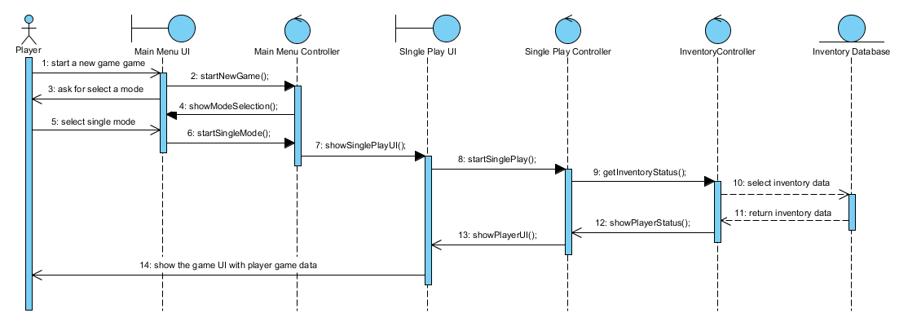

**Create a multi play game room**

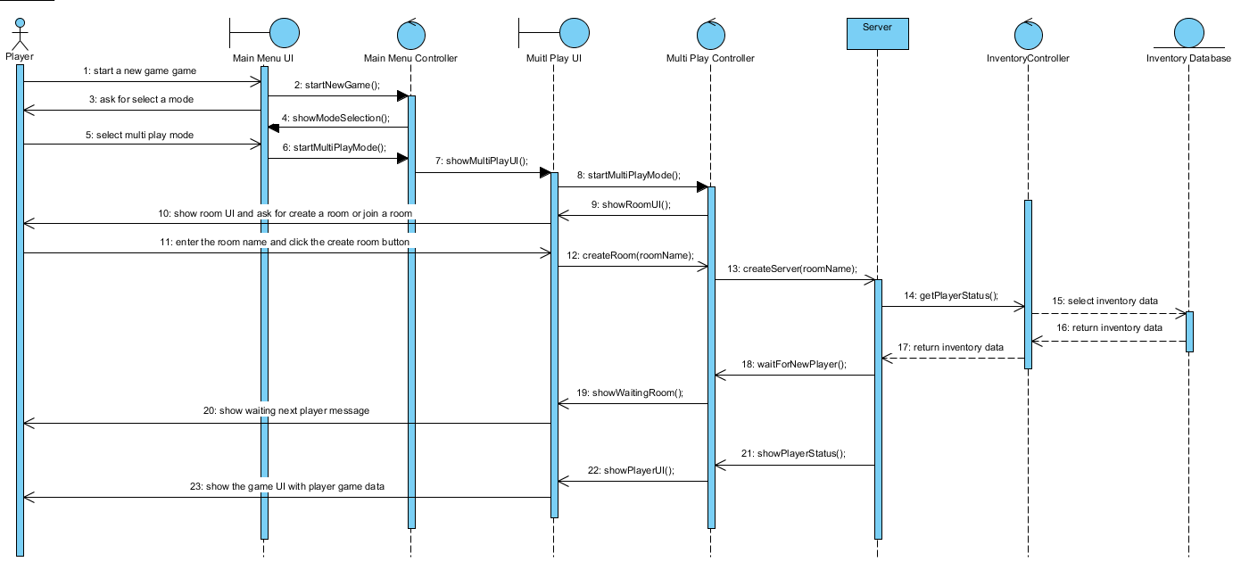

Join a multi play game

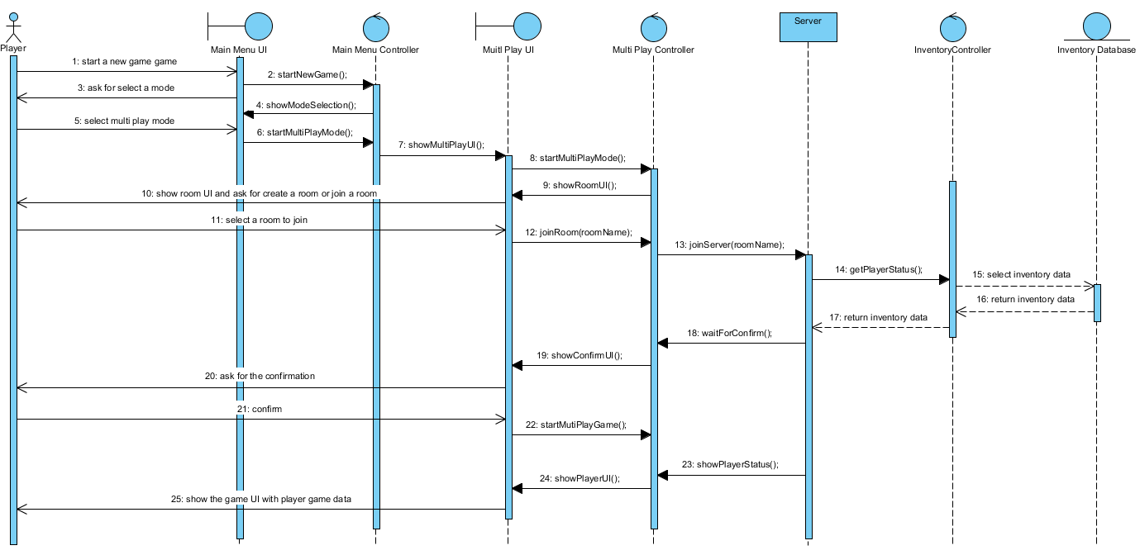

## Database Design

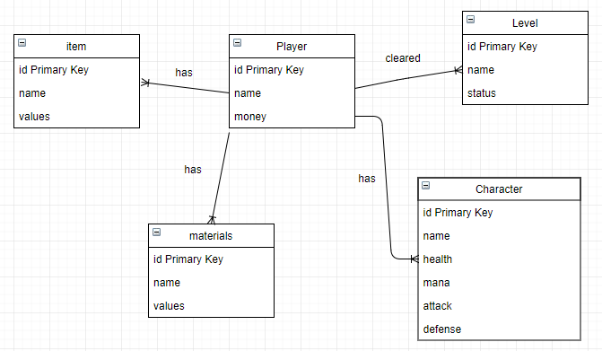

Player Table

|  |  |
| --- | --- |
| Attribute | Description |
| id | id is primary key for uniquely identify each player in the game. |
| name | name is the player’s name |
| money | money is the goal the player had in the game. It is used to buy item from the NPC. |

item Table

|  |  |
| --- | --- |
| Attribute | Description |
| id | id is primary key for uniquely identify each item in the game. |
| name | name is the item name |
| value | value is the number of the item the player had in the game. |

Level Table

|  |  |
| --- | --- |
| Attribute | Description |
| id | id is primary key for uniquely identify each level in the game. |
| Name | name is the level name |
| Status | status is to determine the level has been passed by player or not. |

Character Table

|  |  |
| --- | --- |
| Attribute | Description |
| id | id is primary key for uniquely identify each character in the game. |
| name | name is the character name |
| health | health is the health point of the character have |
| mana | mana is the mana point of the character have |
| attack | attack is the attack value of the character have |
| defense | defense is the defense value of the character have |

Material Table

|  |  |
| --- | --- |
| Attribute | Description |
| id | id is primary key for uniquely identify each material in the game. |
| name | name is the material name |
| value | value is the number of the material the player had in the game. |

# Hardware and Software Requirements

**Target platform**

* Personal Computer
* Android mobile device

**Hardware for development**

|  |  |  |
| --- | --- | --- |
| **Hardware Components** | | **Quantity(s)** |
| **/** | PC | 4 |
| **Requirement of PC** | | |
| CPU: | Intel core i5-8400 | 4 |
| GPU: | Nividia GeForce GTX 1080 | 4 |
| Memory: | Team Dark 2x8GB DDR4-3000 | 4 |
| Power supply: | Corsair CS650M | 4 |
| Case: | Phanteks Eclipse P400 | 4 |
| Motherboard: | Asus Prime Z370-P | 4 |
| Storage: | Samsung 960 Evo 500GM M.2 SSD | 4 |
| CPU Cooler (Optional): | Cooler Master Hyper 212 Evo | 4 |
| **Others Peripheral Device for PC** | | |
| Monitor: | Asus ROG Swift PG279Q | 4 |
| Wired mouse: | AmazonBasics 3 Button USB | 4 |
| Wired keyboard: | Microsoft Wired Keyboard 600 | 4 |
| Speaker: | Logitech Z313 | 4 |
| **Android OS Device** | | |
| Mobile Phone | One Plus 3 | 1 |
| / | Samsung Galaxy Note 7 | 1 |

**Software for development**

|  |  |  |
| --- | --- | --- |
| **Software Components** | | **Quantity(s)** |
| **Software** | **Version** | / |
| Unity | Unity5.0 or above | 4 |
| 3DS Max | 3DS Max 2016 or above | 4 |
| Android Studio | Android 4.0.3 or above | 4 |
| Eclipse | Eclipse4.6 or above | 4 |
| Microsoft Windows | Vista/7/10 | 4 |
| Microsoft Access | 2016 | 1 |
| **Development program language** | | |
| C++, C#, JavaScript | | |

**Hardware for Gaming**

|  |  |  |  |
| --- | --- | --- | --- |
| **Components** | | **Advanced Requirement** | **Minimum Requirement** |
| **Requirement of PC** | | | |
| CPU: | Intel core i5-8400 | | Intel core i5-8400 |
| GPU: | Nividia GeForce GTX 1060 or above | | Nividia GeForce GTX 1050 |
| Memory: | Team Dark 2x8GB DDR4-3000 | | Team Dark 1x8GB DDR4-3000 |
| Power supply: | Corsair CS650M | | Corsair CS650M |
| Case: | Phanteks Eclipse P400 | | Phanteks Eclipse P400 |
| Motherboard: | Asus Prime Z370-P | | Asus Prime Z370-P |
| Storage: | Samsung 960 Evo 500GM M.2 SSD | | HDD or SSD |
| CPU Cooler (Optional): | Cooler Master Hyper 212 Evo | | Cooler Master Hyper 212 Evo |
| **Others Peripheral Device for PC** | | | |
| Monitor: | Asus ROG Swift PG279Q | | Asus ROG Swift PG279Q |
| Wired mouse: | AmazonBasics 3 Button USB | | AmazonBasics 3 Button USB |
| Wired keyboard: | Microsoft Wired Keyboard 600 | | Microsoft Wired Keyboard 600 |
| Speaker: | Logitech Z313 | | Logitech Z313 |
| **Android OS Device** | | | |
| Mobile phone devices: | Mobile phone with Android 6.0 or above | | Mobile phone with Android 4.0.3 |

**Software for Gaming:**

|  |  |  |
| --- | --- | --- |
| **Components** | **Advanced Requirement** | **Minimum Requirement** |
| **Operating System(PC)** | **Windows 7/10** | **Window 7** |
| **Operating System(PC)** | **Android 6.0 or above** | **Android 4.0.3** |

# Technical Considerations

**Functional Requirement:**

* **Health Count function:** If any unit get opponents’ hit, it’s health bar will reduce.
* **Select Character function:** Player can select controllable character to action by clicking the character.
* **Skills Attack function:** By selecting different skills, different character can use different skill to attack opponent
* **Move function:** Player allows to move the character in battle environment by clicking the grid. Player and AI unit is not allowing to move through the obstacle.
* **Item Using function:** Player can use different item to perform different effects.
* **Inventory System:** Player allows to manage the item (such as manage item quantity, using item) by using this system.
* **Energy Count function:** If Ultimate is used, energy bar will reduce to 0. Character cannot use any skill if the energy becomes 0.
* **Compose System function:** Player allows to compose items by using different materials.
* **Trap function:** Player allows to set the trap in the battle environment. If enemy trapped, the specific effect will be performed.

**Non-functional Requirement:**

* **Round Count function:** System will record the round time player pass through.
* **Sound Setting:** Player can customize the sound volume.
* **Difficulty increment:**  when one level is completed and proceed to the next level.
* **Multi-play function:** Player allows to play with another player to complete the special stage.
* **Skills Effect:** When characters use different skills, the skills effect should include explosion effect so to make the fight more intense and existing
* **Health bar reduce animation:** When health bar is reduced, the reduce part show be red color to let player know how much health did reduce during the attack
* **Sound Effect:** fighting sound effects should be exciting so player can feel and enjoy the attack
* **Story Path Decision function:** Player allows to select different path to different ending of the game story.

# Project Plan

## Schedule

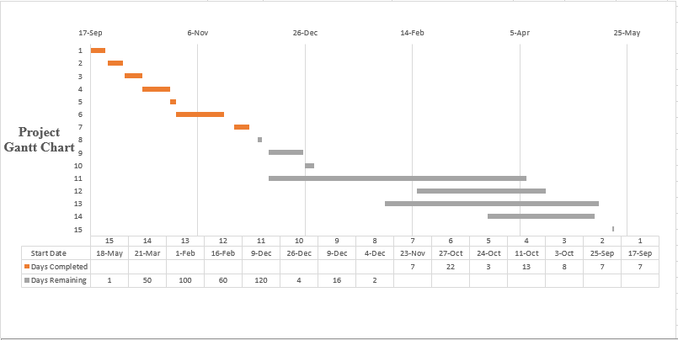

## Milestone Description

|  |  |  |
| --- | --- | --- |
| **Task No:** | **Task Description** | **Expected Completion Date** |
| **1** | Determine the Game Type | 7-Jan-2017 |
| **2** | Finish and submit game proposal | 7-Jan-2017 |
| **3** | Do research to similar type of game | 10-Oct-2017 |
| **4** | Test some of the function | 23-Oct-2017 |
| **5** | Division of labor on initial report | 26-Oct-2017 |
| **6** | Submit the initial report for the first time | 23-Nov-2017 |
| **7** | Finish and submit the latest version of initial report | 29-Nov-2017 |
| **8** | Division of labor on interim report and game development | 6-Dec-2017 |
| **9** | Submit the interim report for the first time | 25-Dec-2017 |
| **10** | Submit the latest version interim report and prepare first oral presentation | 31-Jan-2018 |
| **11** | Start the game development | 1-Apr-2018 |
| **12** | Testing the game | 10-May-2018 |
| **13** | Submit the final report for the first time | 20-Mar-2018 |
| **14** | Submit the latest version final report and prepare second oral presentation | 17-May-2018 |
| **15** | Demonstration of the game | 18-May-2018 |

## Action Plan for (the first Prototype)

|  |  |
| --- | --- |
| **Functions Implement** | **Brief Description** |
| Board Function | Game Board |
| Attack Function | Player can attack the object |
| Move Function | Player can move to wanted position within the range |
| Skill Function | Some character can build or set trap on the map |
| Active Environment Function | Player can active the object or special region on the map to achieve some goal (Push down the tree to stop the enemy moving to the direction) |
| Enemy Move Function | Enemy AI can successfully perform the move/attack function |
| Equip Item Function | Player can equip some item and the status of character will increase |

**Expected feedback**

* The first prototype is playable
* The main functions can work properly
* Enemy AI can perform wanted move
* The game play is unique compare to the general SRPG
* The game could be fun
* The idea of the game is workable

# References

**Graphical Materials:**

ゆうひな(ツクール素材配布ブログ)

<http://blog.goo.ne.jp/akarise>

JewelSaviorFREE

<http://www.jewel-s.jp/>

王国興亡記

<http://makapri.web.fc2.com/top.html>

CLOSET

<https://sites.google.com/site/closetvx/>

**Audio:**

魔王魂

<https://maoudamashii.jokersounds.com/>

Atelier Nonta

<http://www.ateliernonta.com/freemusic.html>

MoonWind

<http://moonwind.pw>

**Libraries:**

Vuforia

<https://developer.vuforia.com/>

**Software:**

Unity

<https://unity3d.com/>

3Ds Max

<https://www.autodesk.com/products/3ds-max/overview>

# Appendices

## Workload Distribution

**Development Team:4 people**

**Leader:** LAM Ka Kuen(LAM)

**Member:** IP Hau Man(IP)

MO Chun Tat(MO)

CHIU Man Hin(CHIU)

**Workload Distribution**

|  |  |
| --- | --- |
| **Area** | **Person/People in charge** |
| Game Proposal/Document | IP, MO, LAM, CHIU |
| Game Designer | IP, MO, LAM, CHIU |
| Programmer | IP, MO, LAM, CHIU |
| Artist | IP, MO, LAM, CHIU |
| Musician | IP, MO |
| Script Writer | IP, MO |
| Tester | LAM, CHIU |

## Budget Estimation (Reference)

|  |  |  |
| --- | --- | --- |
| Components | Quantity | Cost(HKD) |
| CPU | 4 | 2000 |
| GPU | 4 | 12000 |
| Memory | 4 | 3200 |
| Power supply | 4 | 2000 |
| Case | 4 | 2400 |
| Motherboard | 4 | 2800 |
| Storage | 4 | 2000 |
| CPU Cooler (Optional) | 4 | 1200 |
| Monitor | 4 | 4800 |
| Wired mouse | 4 | 600 |
| Wired keyboard | 4 | 600 |
| Speaker | 4 | 800 |
| One Plus 3 | 1 | 3000 |
| Samsung Galaxy Note 7 | 1 | 6000 |
| Unity | 4 | 6000 |
| 3DS Max | 4 | 5400 |
| Android Studio | 4 | 0 |
| Eclipse | 4 | 0 |
| Microsoft Windows (Operating System) | 4 | 8000 |
| Microsoft Access (Database) | 1 | 2000 |

**Important Note: All the hardware and software device are already well prepared. Therefore, the real budget should be HKD$0**

## Log Sheets

|  |  |
| --- | --- |
| Course/Class: ITP114107/2C | Project ID: |
| Supervisor: Willison Cho | Date: |
| Project Title: Noah | |
| Student Name(s): Ip Hau Man, Lam Ka Kuen, Chiu Man Hin, Mo Chun Tat | |

|  |  |
| --- | --- |
| Work done & findings since last recording | Logged by |
| |  | | --- | |  | | 1. Finish and submit the latest version of initial report. 2. Division of labor on interim report and prototype implementation. 3. Labor do further research on the responsible implementation. 4. Implementation. 5. Testing for implementation (functions like multi-play through UNET). 6. Submit the latest version prototype and interim report. | | IP Hau Man |
| State which part of the last plan not yet finished (leave it blank if you finished all the work of the last plan | Logged by |
|  |  |
| Plan of work before the next recording | Logged by |
| Develop more functions like AI, character attribute, UI style design, 3D character building and combine all Labor’s works into one project. | IP Hau Man |

|  |
| --- |
| Supervisor’s comment on student’s work |
|  |

|  |  |  |
| --- | --- | --- |
| Student’s Signature: |  | Supervisor Signature |